University of Cambridge Apprenticeship Awards 2021
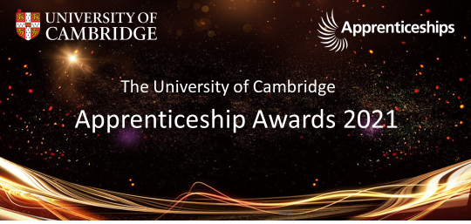

The inaugural University of Cambridge Apprenticeship Awards 2021 were held on Wednesday 23 June celebrating and recognising the positive contributions that apprentices are making across the University.
Following nominations from across the University, Awards were given for:
- Apprentice of the Year 2021– Intermediate, Advanced, and Higher or Degree apprenticeships
- Apprenticeship Champion of the Year 2021
Plus a surprise award:
- Rising Star 2021

This event, which was held virtually, was co-hosted by Colin Long and Leonie Isaacson from Personal and Professional Development and featured an introduction from the Vice-Chancellor, Professor Stephen Toope, followed by a welcome address from Pro Vice Chancellor for Strategy and Planning, David Cardwell. David also announced the winners and runners up to the various awards. Videos of a selection of apprentices discussing their apprenticeship journeys were shown during the event.
In addition to the nominated awards, there was an additional surprise award. During the judging process, the judges were so impressed with the journey and progress of some apprentices that a decision has been made to create a new category – the Rising Star award.
David Cardwell commented: ‘It’s extremely pleasing to see so many individuals across the University thriving on our apprenticeship programmes. It’s abundantly clear from these awards that the standard is consistently exceptionally high and that the level of engagement is extremely impressive. I wish all apprentices within the University continued success, which I look forward to celebrating at similar events in the future’.
2021 winners, runners up and nominees – full list (Raven login required)
Very many congratulations go to all the nominees and winners.
A recording of the full event is available to watch online (Password 9mEN=Yw2). The videos shown at the awards plus videos of apprentices will be available soon to view via the Apprenticeship website.
The website also contains more information on apprenticeships including guidance for prospective apprentices and managers. To learn about forthcoming apprenticeship information webinars please sign up to the PPD Bulletin. Alternatively, you can contact Colin or Leonie via Apprenticeships@admin.cam.ac.uk

