5-STEP GUIDE: WORKFORCE PLANNING
AT THE SCHOOL AND INSTITUTIONAL LEVEL

What?
A practical, systematic process for identifying and addressing gaps between current staffing and areas of future need, tailored to school-level requirements.

Why?
- Retain, recruit and develop staff with the required skills and diversity to meet the university’s mission and the institutions’ strategic plans
- Identify talent gaps based on available HR data and trends in our evolving higher education landscape
- Anticipate and prepare for key vacancies, supported by succession planning
- Engage stakeholders in a coherent, multi-year vision (vs. reactive, short-term thinking)
- Implement creative approaches (eg career development, collaborations, job re-design, apprenticeships)
- Support wellbeing, workload management and positive workplace environment

Table of contents

- Getting started FAQs

- 5-Step workforce planning:
  - Step 1: Establish planning roles and process
  - Step 2: Identify and analyse workforce gaps
  - Step 3: Develop plan to close workforce gaps
  - Step 4: Implement workforce plan
  - Step 5: Monitor and communicate
  - Workforce plan approval and contact page

- Conclusion FAQs

- References and additional resources

- Annex (HR metrics and workforce data)

- Definitions and links

Getting started FAQs

What is workforce planning?
For the purposes of this guide, we define workforce planning as a practical, systematic process for identifying and addressing gaps between current staffing and areas of future need.

Does Cambridge University need to be concerned?
To maintain excellence, it is essential to attract, retain and motivate talented staff (HEFCE). The nature of universities is changing, bringing changed demands in terms of staff and skill sets required (IES). The UK labour market has tightened and employee turnover has increased. Academic recruitment difficulties are most commonly reported in STEM areas. For professional staff, there are challenges recruiting specialists in IT, estates, marketing, HR and finance (UCEA). UK higher education cannot reach its full potential unless it can benefit from the talents of the whole population and until individuals from all ethnic backgrounds can benefit equally from the opportunities it affords (Equality Challenge Unit).

Why do universities have workforce plans?
Workforce planning is a proactive process for:
- Retaining, recruiting and developing staff with the required skills and diversity to meet the university’s mission and the institutions’ strategic plans
- Identifying talent gaps based on available HR data and trends in our evolving higher education landscape
- Anticipating and preparing for key vacancies, supported by succession planning
- Engaging stakeholders in a coherent, multi-year vision (vs. reactive, short-term thinking)
- Implementing creative approaches (eg career development, collaborations, job re-design, apprenticeships)
- Supporting wellbeing, workload management and positive workplace environment

Is there a “best practice” for university workforce planning?
There is no ‘one size fits all’ or single model for workforce planning that can be applied across all organisations. It is about developing processes which suit the particular organisation, its culture and ways of working (CIPD). There does not need to be a slavish adherence to a best practice as higher education circumstances have distinctive features (IES).

Who is responsible for workforce planning?
Workforce plans are not developed in isolation. They require engagement, consultation and data analysis at many levels. Workforce planning requires an appropriate division of activity between the university centre schools/institutions, and how they connect (IES). This guide was developed by the HR Division in consultation with school stakeholders. In Step 1, the schools determine who will be involved at the school level.

How is workforce planning related to other human resource practices?
A wide variety of activities take place under the workforce planning banner: succession planning; flexible working; demand/supply forecasting; skills audit/gap analysis; diverse recruiting; talent management; multi-skilling; role design; risk management; outsourcing; career planning; scenario planning (CIPD). Appraisal systems (eg SRD) generate information and discussions with employees about their current job performance and the skills they are demonstrating. If the quality of performance management is poor, there is no firm foundation from which to build (IES).

How does workforce planning relate to budgeting processes?
To close the planning loop, workforce planning should feed into the budgeting process so the costs of actions and staffing levels are estimated and included in budgets. Workforce planning is a valuable process to help inform annual resource planning, projections and forecasting (IES).

Please also refer to conclusion FAQs on page 12.

5-step workforce planning

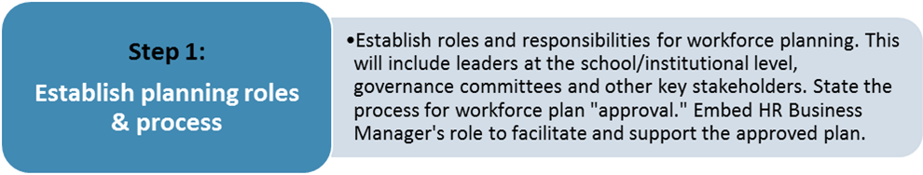

Establish roles and responsibilities for workforce planning:
- Leaders at the school/institutional level
- HR Business Manager
- Governance committees
- E&D consultants
- Key stakeholders
- Other

How will plan be “approved”?

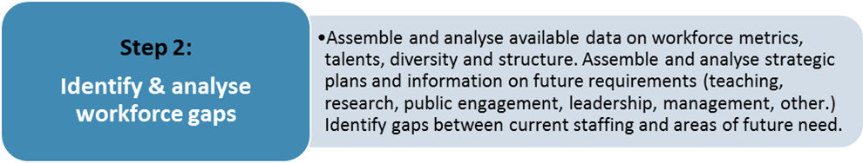

Step 2A: What are your current resources?
- Assemble data on what you currently have: headcount, vacancies, staff type, gender, nationality, ethnicity/race (BME), age, staff reaching retirement age, turnover rates (see Annex page 12); organisational charts; budget.

Vacancies (current)
Vacancies (anticipated)
Anticipated retirements (1-5 years)
Critical roles (eg key leadership roles; jobs with “single person” dependency)
Describe the diversity of the workforce (gender/ethnicity/race by grade)
Key workforce challenges (eg unsuccessful searches, turnover, work overload, underrepresentation of key diversity groups)
Staff with current or emerging talent in key areas (eg teaching, research, leadership, management, public engagement, technical skills, specialist skills)
Does current staffing and organisational structure support your objectives?

Step 2B: Where are you going and what is needed in the future?
- Assemble information and documents on future strategic direction: university strategies; school strategies; institutional strategies; People Strategy; Athena SWAN/Race Equality Action Plans; higher education trends, etc.

New talents needed to succeed in future:
- new curriculum/research/public engagement capabilities
- leadership/management skills
- other technical or specialist skills
Skills or roles no longer required?
Where is increased diversity required to achieve stated commitments and objectives?
What staffing/organisational changes are needed to support new delivery of activities or programs?

Step 2C: Gap analysis
- In this step, we identify gaps between current staffing and areas of future need.

Identify the key, strategic gaps:
- Talent / skills gaps
- Gaps in staffing numbers
- Diversity gaps
- Organisational/structural gaps
Prioritise gaps that are most critical

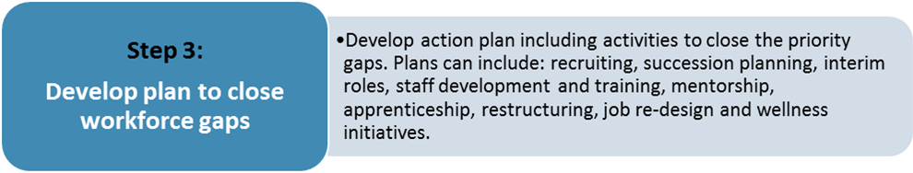

Action Plan to close the workforce gaps  (select all that apply) | Details of implementation at school and institutional level | To address which gap(s)?
- Acting or interim roles (internal)
- Secondments
- Succession plans to build talent pipeline
- External recruitment
- Inclusive recruitment (diverse advertising outlets, networks and inclusive language)
- Job shadowing
- Training for culture change and inclusive cultural awareness
- Training and development for new talent/skill development
- Mentorship
- Apprenticeship
- Organisational restructuring
- Collaborations across departments
- Job re-design
- Flexible work/job sharing
- Wellbeing initiatives and management of work pressures
- Other

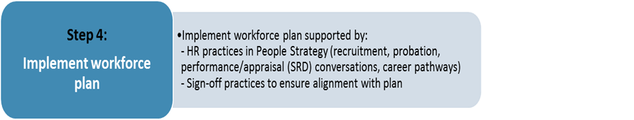

In Step 4, the School proceeds to implement the actions stated in the Step 3 template above.

However, it is difficult to start thinking about workforce planning without simultaneously following good HR practices. For example, appraisal systems (SRD) and performance conversations generate information on career aspirations of staff and feeds into succession plans, training plans and career pathways. Good HR practice is the foundation for successful workforce planning, along with increased awareness of the cultural changes needed to support diversity.

HR Practices included in People Strategy  (select all that apply) | Details of implementation at school and institutional level
- Enhanced recruitment practices
to recruit using rigorous, fair, flexible and professional selection methods
- Induction and probation for all staff categories
to ensure expectations are clear and give employees the best possible start
- Appraisal (SRD), performance and retirement conversations
to support people throughout their careers at Cambridge
- Career pathways for academic and non-academic
to provide structured routes to career progression for both academic and professional careers
- Wellbeing initiatives
for reduced workplace stress, reduced absence, and more productive working and engagement
- Reward strategies
including fair starting salaries, pay progression, contribution schemes, promotion schemes, market pay, etc.
- Other talent management initiatives
to contribute to the personal and professional development of staff as part of a high performance culture

Describe the sign-off process for key recruitment decisions (to ensure alignment with workforce plan)

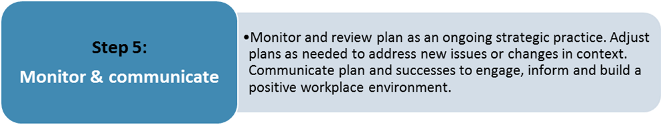

How will workforce plan be monitored and reviewed?

Process for making changes to workforce plan?

How will plan be communicated?

Workforce plan approval and contact page

Name of School: [enter name of school]

Date plan approved: [enter date]

Senior School Leader: [enter name of senior school leader responsible for workforce plan]

HR Business Manager: [enter name of HRBM]

Conclusion FAQs

Is workforce planning distracting if we have immediate vacancies to fill?
Workforce plans should not be overly complicated but they must address both current and future needs. The plans need to be robust enough to manage in the short term while flexible enough to cope with longer term scenarios (CIPD). Workforce planning provides an important opportunity for those understandably bogged down in day to day activities to focus on the future. The process facilitates discussion that is less concerned with getting the right answer than ensuring that the questions get asked in the first place (IES).

If we have HR data limitations, can we still get started on workforce planning?
Workforce planning is as much art as science. No formula exists for a workforce plan which is ‘correct’ to the finest level of detail. So much data is available to inform workforce planning that the art comes in bringing it all together (CIPD).

What are the objections to workforce planning?
Lack of workforce planning, in many cases, stems from the preferences of senior academic leadership for ad hoc, decentralised decision making. With the frequency, unpredictability and depth of change, people may take the view that planning in an uncertain world is doomed to failure. Workforce planning has been critiqued as too complex, too inflexible and too slow (IES). Many of the criticisms are understandable, but are they acceptable? Can we say that just because it is difficult to plan we should not do so? Surely, we need to have resources correctly mobilised to ensure ambitions are delivered? To implement successful workforce planning, it is important to discuss and address these common objections (IES).

How do we achieve “buy in” and deal with objections?
As the workforce plan is developed, it is important to build consensus through wide-ranging consultation with internal and external stakeholders. Good workforce planning results in a plan that all parties can agree to, based on clear rationale for the actions that need to be taken. There should be ‘no surprises’ when it is communicated and implemented (CIPD). To engage senior leaders in the process of workforce planning, it is important to communicate the benefits of planning as well as the risks of ignoring it (IES).

How can workforce plans remain relevant in the face of constant change?
Workforce planning is not a one-off activity. You will need to review and visit the plan, not allow it to sit unchanged (IES). To be useful, workforce plans should be a ‘living’ document. They need to be constantly refreshed. Much of the value of workforce planning comes from the process of working to understand future workforce needs. Review should be embedded into the process of workforce planning with information on outcomes feeding back into the planning cycle (CIPD).

How will we know if workforce planning is working?
There is rarely a celebration or much applause for successful workforce planning. However, you will know when you’ve succeeded when: businesses are running smoothly, with no staffing crises; you have a good age, gender and ethnicity balance across the workforce and grades; and your staff have clearly understood career progression routes (IES). Formal techniques to evaluate progress of the workforce plan include: program process reviews, employee questionnaires, surveys, focus groups, organisation performance assessments and lessons learned sessions (NIH).

References and additional resources

Workforce planning theory, tools and guides

- Workforce Planning Guide
Chartered Institute of Personnel Development (CIPD)
www.cipd.co.uk/Images/workforce-planning_2010-right-people-time-skills_tcm18-9058.pdf

- Workforce Planning Guide
Institute for Employment Studies (IES)
www.employment-studies.co.uk/system/files/resources/files/451.pdf

- How to Guide: Planning and Performance: ‘Strategic Workforce Planning’
University of Liverpool
www.liverpool.ac.uk/media/livacuk/hr-migrated/organisational-development/Strategic,Workforce,Planning.pdf

- Strategic Workforce Planning Guide: How to Create Your Own Strategic Workforce Plan
National Institutes of Health (NIH)
hr.nih.gov/help/faq/working-nih/workforce-planning

- The Human Capital Institute Strategic Workforce Planning Model
University of California
ucnet.universityofcalifornia.edu/working-at-uc/your-career/talent-management/talent-planning/strategic-talent-planning.pdf

Workforce trends and issues in UK higher education

- Workforce Planning in Academic Institutions
A report for Universitas 21, Institute for Employment Studies (IES)
www.universitas21.com/RelatedFile/Download/556

- Higher Education Workforce Survey 2017
Universities & Colleges Employers Association (UCEA)
www.ucea.ac.uk/en/publications/index.cfm/hews2017

- The Higher Education Workforce Framework
Higher Education Funding Council for England (HEFCE)
www.hefce.ac.uk/pubs/year/2010/201005a/

Succession planning
- Preparing Leaders of the Future
American Council on Education
www.acenet.edu/news-room/Pages/Preparing-Leaders-for-the-Future.aspx

- Succession Planning
Chartered Institute of Personnel Development (CIPD)
www.cipd.co.uk/knowledge/strategy/resourcing/succession-planning-factsheet#15763

Annex: HR metrics and workforce data

To support workforce planning, the HR Division produces a range of HR metrics and workforce reports. These are provided as annual, termly or monthly reports (as indicated below.) As workforce planning moves forward, we will identify other standard reporting artefacts to support the process.

HR Dashboard at School Level | - a monthly school-level report available from HR Business Managers which includes: headcount by staff type; starters, leavers, turnover %; wage bill; sickness; gender (female %); nationality; contract %; staff reaching retirement age
Establishment Listing / Retirements | - issued annually by report burst in the Michaelmas Term; covers only University Officers  - includes year of retirement (the date is always 30 September)  - also includes the underlying office, for example, posts held in abeyance as a result of senior academic promotions. This information may help schools to plan if they want to recruit at a higher level.
General workforce profile | - monthly staff listing burst report to departments  - includes staff group, age information, length of continuous service, (which might help anticipate retirement rates in staff groups with no fixed retirement age)
Equality dashboard | - a range of equality and diversity statistics are available from E&D Consultants in the HR Division (eg gender, BME, applications, offers, promotion success metrics, staff balance across grades)
Data on workforce challenges | - the school-level HR Dashboard includes a number of metrics, including turnover rates  - report on sickness absence over the last 12 months (quarterly burst to departments)  - the monthly pay transactions report identifies areas which are heavy users of overtime, which might indicate work overload
Sabbatical Leave | - the termly burst report of upcoming sabbatical and other academic leave to School Offices to plan for reduced FTE, teaching duties, etc.
Organisation structure | - “Working Patterns and Reporting Managers” report (monthly burst to departments) shows manager / employee reporting relationships. This information is maintained locally in CHRIS by institutions. Otherwise, institutions can maintain their reporting manager and organisational charts on a local basis.

Definitions and links

Apprenticeship www.apprenticeships.admin.cam.ac.uk/

Diversity www.equality.admin.cam.ac.uk/

Flexible working www.hr.admin.cam.ac.uk/policies-procedures/flexible-working

Job shadowing www.ppd.admin.cam.ac.uk/professional-development/job-shadowing

Leadership development www.ppd.admin.cam.ac.uk/leadership-development

Mentorship www.ppd.admin.cam.ac.uk/professional-development/mentoring-university-cambridge

Organisational change www.hr.admin.cam.ac.uk/policies-procedures/organisational-change-guidance/organisational-change-guidance-1

People Development www.training.cam.ac.uk/cppd/theme/peopledev?providerId=36612

People Strategy www.hr.admin.cam.ac.uk/people-strategy

Probation www.hr.admin.cam.ac.uk/policies-procedures/probationary-arrangements

Professional development www.ppd.admin.cam.ac.uk/

Race equality www.ecu.ac.uk/equality-charters/race-equality-charter/about-race-equality-charter/

Recruitment guidance www.hr.admin.cam.ac.uk/recruitment-guidance

Secondment www.hr.admin.cam.ac.uk/policies-procedures/secondment-policy www.ppd.admin.cam.ac.uk/professional-development/secondments

Staff Review and Development www.ppd.admin.cam.ac.uk/career-development/staff-review-and-development

Wellbeing www.wellbeing.admin.cam.ac.uk/

